Budgeting Policy 18-19

In brief

- Your work as a committee member on your club’s budget this year will dictate what your club is eligible to receive in terms of funding from the CSP grant.

- The budgeting methodology we follow attempts to split the grant as fairly as possible.

- The grant exists to support activity, not fully fund it. The rest of the costs are covered by income such as membership, sponsorship and other fundraising.

- This budget is not just for grant allocation, it is for the club to predict their costs for the following year and then use as a working document throughout the year to prevent going into debt.

- This policy explains the guidelines that the committee follows to help allocate funds fairly.

- When you submit your budget, do not copy and paste last year’s as you may be running new activities in comparison (which will cost the club more if the budget is not updated), your costs may have also increased.

- Be specific, and succinct in your descriptions. Make sure to split up your activities into different activity budgets / lines where possible to avoid confusion. “20 minibuses for all 1st team training sessions” and then “20 minibuses for all 2nd team training sessions” is much better than “We need to book 40 minibuses for weeks spanning both terms in order for our first and second teams to train”

- Be honest, we want to support all students fairly, don’t lie on your budget (see club conduct). Any club that lies on their budget may forfeit their grant based on decision by CSPB.

Introduction

This document was produced by the Club, Societies and Projects Board (CSPB). The discussions surrounding the content of the document have centred on key issues that have been raised during the main budgeting process in the years since CSP budgeting was centralised to CSPB.

Decisions enforced by this policy, and the policy itself, may be amended by 2/3 of the members present at a meeting of the Clubs, Societies and Projects Board.

Timeline

The budgeting process for the 18/19 session will take place between 7 December 2018 and 15 March 2019. Key dates are as follows:
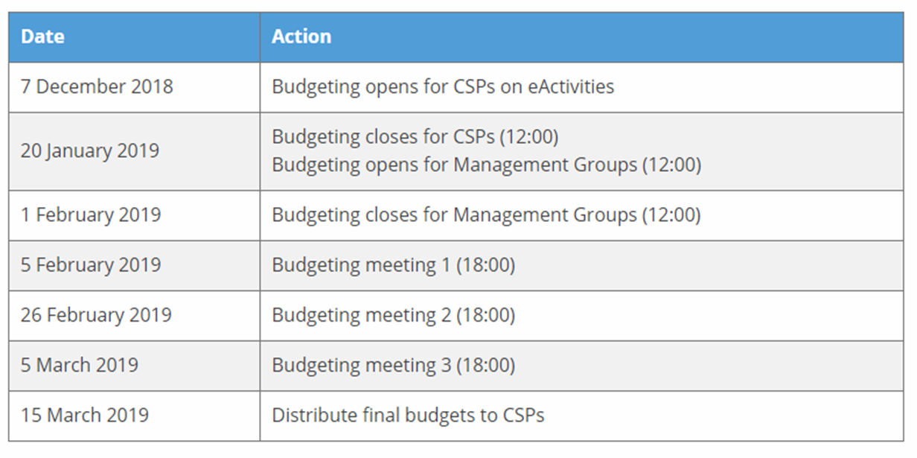
Membership of the Committee

The committee who will be making budgeting decisions for the academic year 2017/18 is the Clubs, Societies & Projects Board. The membership of this committee, and the representatives for each society, are also contained in the table below. You should contact the relevant contact of your constituent union/ management group if you have any questions.

Constituent | Name | Contact email
Union/Management Group
Arts & Entertainment (AE) | Joseph O’Connell-Danes | ae.chair@ic.ac.uk
Sports Sector (ACC) | Thomas Fernandez-Debets | sport.chair@ic.ac.uk
Community & Faith Sector (CF) | Hoi-Ming Yau | cag.chair@ic.ac.uk
Culture Sector (CT) | Chimdi Igwe | osc.chair@ic.ac.uk
Recreation Sector (RCC) | Thomas Pleece | rcc.chair@ic.ac.uk
Knowledge Sector (KN) | Daniel Wigh | knc.chair@ic.ac.uk

City & Guilds College Union | Andrew Hill | engineering.president@imperial.ac.uk
(CGCU)
Graduate Students’ Union | Ute Thiermann | gsu.president@imperial.ac.uk
(GSU)
Imperial College School of | Tom Willis | icsm.cs@imperial.ac.uk
Medicine Students’ Union
(ICSMSU)
Royal College of Science | Michael Mcgill | rcsu.president@imperial.ac.uk
Union
Royal School of Mines Union | Anthony Onwulli | rsm.vpcs@imperial.ac.uk
Budgeting Categories

There will be 4 budgeting categories, into which each budgeting line should fall.

Core - Core Operational expenditure
Non-core - Non-core/unsubsidized Expenditure Exec - Office/Stationery Expenditure
Welfare - Welfare Expenditure

Whilst clubs are expected to label their budgeting lines using these categories, CSPB hold the power to reallocate the category at any point during the process.

They will judge this based on the Aims and Objectives that the club submits as part of their budget. These should be ranked in terms of importance. i.e. “1-Most Important” would be for something your club could absolutely not function without, and “3” something that would be incredibly useful, but not essential.
In general please do not try to put all activities as “core” unless they absolutely are. We would expect most clubs to have a mix between core and non core.

Key Decisions & Priorities

Club Conduct

A 2/3 majority of the committee may, in the event that deliberate deceit is discovered during the budgeting process, reduce a club’s allocation to £0. This can be appealed during the appeals funding round, in which the remaining funds from the two previous meetings will be allocated.

The budgeting policy, in particular those sections relating to sponsorship & SGI amounts, rewards clubs that run their entire turnover through the Union system. Budgets will be judged against previous year’s expenditure.
Funding schema

Budgeting Lines and Appeals will be discussed according to the schema below – which are aimed to provide a common language and framework. The schema have been prioritized as follows – that is to say, need is considered more important than the reach of an activity.

All budget lines should be justified with direct reference to these headings, and should aim to fulfil the requirements of as many as possible.

Need Funding allocated based on a club needing the funds to run.

Reach Funding allocated based on the number of Imperial Students reached.

Merit Funding allocated based on providing a unique aspect of the student experience.

Priority Funding allocated based on the activity being particularly important as part of the society’s activity.

Effort Funding allocated based on the time put into an application.

High Cost Activity Clubs whose total subsidy per member exceeds £100 should provide strong justification for why the extra Grant significantly benefits their members.

SGI

Levels of SGI above 100% of the average turnover for the past 3 years will require very specific justification within a budget application. This should be for a specific item or type of expenditure that cannot be bought within a single academic year.

In addition, clubs with over £10,000 of SGI will need to provide a justification. These numbers will be based on the closing balance in the club’s accounts at the end of academic session 16/17. Money in a Designated Members Fund (DMF) will not be considered during the budgeting process, except where a budget line directly funds a DMF.

Sports and Minibus Subsidy Subsidy will be available up to the values set by the venues operated by Sport Imperial. These numbers are included in Appendix C – Pricing Matrix for Sport Imperial venues & Minibuses. Exceptions

to this may be made where e.g. using a closer venue reduces the travel costs, or no suitable facility is operated by Sport Imperial.

Printing & Publicity Funding for this will be considered as part of a normal budget. Core Club Printing should be coded under “Printing Costs”, and all such lines will be considered in conjunction with the budgeting criteria.

Sponsorship & College Funding Clubs expecting to receive more than 25% of their annual income in total from sponsorship, donations, and college funding will have their budgets reviewed in detail, and should provide strong justification for their continued requirement for Union Grant. Further clubs may be asked to provide justification during the budgeting process.

Failure to declare expected sponsorship or College Funding will be considered as deceit by CSPB.

Funding for Individual Society Members Subsidy will be available to individual members only in the case that the funds directly benefit the club

as a whole. A maximum of half the cost will be eligible for subsidy.

Health & Safety Expenditure

Health and Safety Equipment & Training Costs shall be considered as normal Equipment & Instructor costs, and will not be eligible for additional funding.

Food & Drink

Food and Drink should be coded under “Hospitality” and will only be funded where consumption of food and drink falls into the core aims & objectives of the club.

Ring Fences

Drafts of budgets for review should be completed by 25 December. The ring fences and their scope will be discussed at the CSPB meeting on 19 January.

The following groups should submit a full budget application for this meeting:

RCC VVMC (614)

RCC RCS Motor (640)

RCC RSM Motor Club (648)

Silwood Exec (550)

For CSPB-E Subsidy:

A&E Felix (381)

ICSMSU Exec (655)

RCSU Exec (730)

RSM Exec (645)

CGCU Exec (600)

A&E Exec (406)
Appendix C – Pricing Matrix for Sport Imperial venues & Minibuses

Facilities |  | Minibuses | 9-seat | 15-seat
Sports Hall /Hr | £48.00 | Up to 2 hours | 21.30 | 28.30
Badminton Court /Hr | £11.60 | 2-4 hours | 36.40 | 52.60
Squash Court /45 min | £3.25 | 4-6 hours | 56.60 | 79.80
Swimming Pool /Hr | £33.00 | 6-12 hours | 75.80 | 101.00
Swim Lane / Hr | £6.60 | 12-24 hours (weekdays) | 99.00 | 130.30
Fitness Studio /Hr | £42.00 12-24 | hours (weekends) | 123.30 | 144.50
Heston (Indoor) | £12.00 | Weekend | 252.50 | 287.90
 |  | Extra days | 43.50 | 56.60
Fuel /mile | £0.28 | Full Week | 426.30 | 514.10
To be updated with 2018/19 prices

